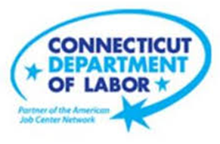

**NEW WEEKLY JOB POSTINGS FROM   
HELP WANTED ONLINE  
Office of Research**

**Week Ending September 5th, 2020   
New Weekly Job Ads Reach Four Week High**

WETHERSFIELD, September 11th, 2020 – During the week ending September 5th, 2020, there were 5,403 new postings. New postings are up 7.5% or 379 ads from a week ago. This one-week increase is driven by Manufacturing (+116 new ads), Educational Services (+101 new ads) and Health Care & Social Assistance (+76 new ads). Fifteen gaining sectors had a combined 541 more new ads than the prior week. These gains were dampened by combined new ad declines of 162 in six sectors, the largest being Professional, Scientific, & Technical Services (-91 new ads), Retail Trade (-48 new ads) and Utilities (-10 new ads). New postings for the week ending September 5th was a four-week high and was the fourth highest weekly count during the past six months. This weekly level is 42% higher than new posting counts from a year ago.

**Industries** with the most new postings include Health & Social Assistance, Retail Trade, and Finance & Insurance.

**Occupations** with the most new postings include Registered Nurses, Retail Salespersons, and Food Customer Service Representatives.

**Employers** with the most new postings include Boston Market, Amazon, and The Hartford.

**The three industries with the most new job postings where**

* **Health Care and Social Assistance** (1,129 new postings, +7% over the week)
* **Retail Trade** (676 new postings, -7% over the week)
* **Finance & Insurance** (454 new postings, -0.2% over the week)

 15 sectors had job posting increases over the week and 6 had decreases. Some of the largest percent increases occurred in Educational Services (+50% or +101 new ads), Information (+48% or +46 new ads), and Other Services (+46% or +41 new ads). The six decreasing sectors were down 91 or less over the week. Some of the largest decreases occurred in Professional, Scientific, and Technical Services (-91 new ads or -30%), Utilities (-10 new ads or -22%), and Retail Trade (-48 new ads or -7%).  
  
For more information on total job ads by industry for Connecticut and its labor market areas, see the monthly report available here: <https://www1.ctdol.state.ct.us/lmi/hwol.asp>

The June 2020 edition of the Connecticut Economic Digest features an article on HWOL: <https://www1.ctdol.state.ct.us/lmi/digest/pdfs/cedjun20.pdf>

**New Job Postings by Occupation**

**The occupations with the most new postings during the week ending 9/5/20 were:**

* Registered Nurses (223 new postings, +5% over the week)
* Retail Salesperson (22 new postings, +13% over the week)
* Customer Service Representatives (146 new postings, +17% over the week)



**Employers with the Most New Job Postings  
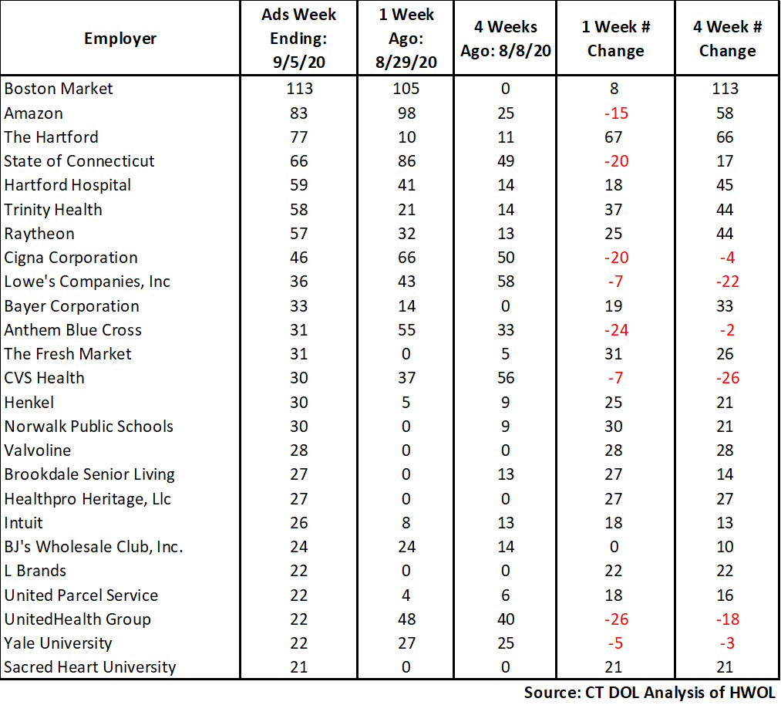**

Employers with the most new job postings for the week ending September 5th were mostly in Retail Trade, Finance & Insurance, and Health Care. The 25 employers shown below account for 19 percent of all new ads for the week ending September 5th, 2020. The employers with the largest increase over the week were The Hartford (+67 new ads), Trinity Health (+37 new ads), and The Fresh Market (+31 new ads). Eight out of 25 employers had over the week declines, the largest were UnitedHealth Group (-26 new ads), Anthem Blue Cross (-24 new ads) and Cigna Corporation (-20 new ads).

**Covid-19 and Weekly New Job Postings**  
In recent months, the pandemic Coronavirus (Covid-19) has caused significant social and economic implications throughout the world.  
  
This HWOL report includes new weekly job postings to illustrate how Covid-19 has impacted Connecticut in the short term and highlight recent job postings in the weeks since the virus disrupted both the economy and labor markets.  
  
**What is HWOL?**The **Conference Board Help Wanted Online**® Data Series (HWOL) measures the number of new, first-time Online job postings and jobs reposted from the previous month for over 16,000 Internet job boards, corporate boards and smaller job sites that serve niche markets and smaller geographic areas.

**To view more HWOL data, go to:** [**https://www1.ctdol.state.ct.us/lmi/pubs/HWOL2020.pdf**](https://www1.ctdol.state.ct.us/lmi/pubs/HWOL2020.pdf)